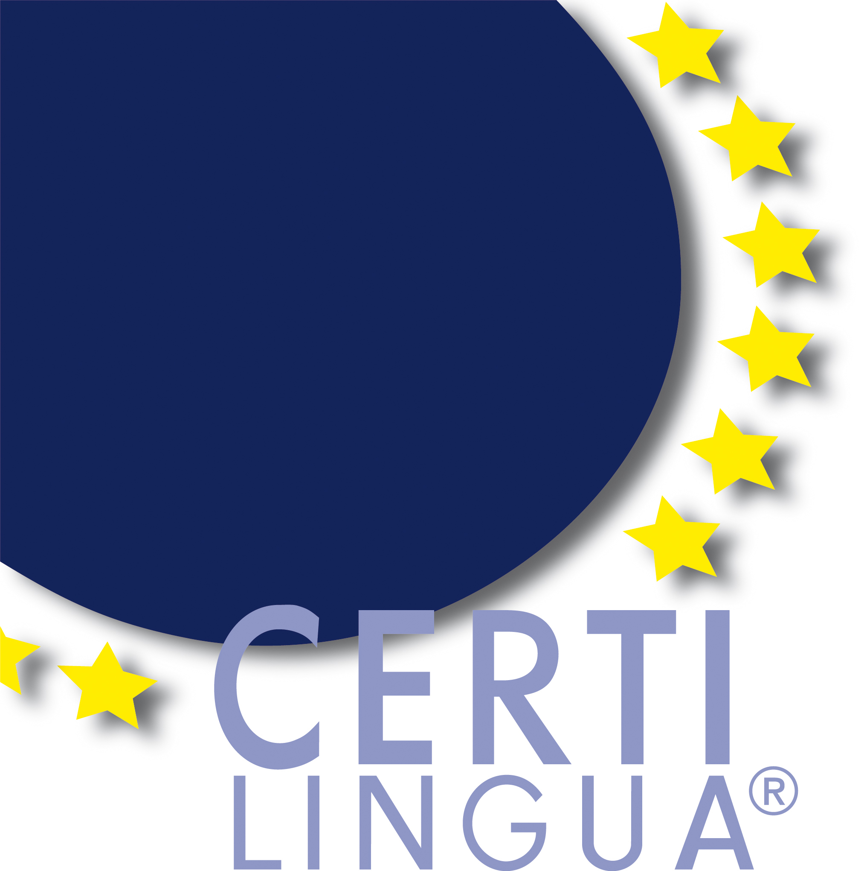
CertiLingua Evaluation Report from Member States
CertiLingua Evaluationsbericht der Mitgliedsländer

Academic Year/ Schuljahr:_____________

due: 31 December of the corresponding year
einzureichen bis: 31. Dezember des entsprechenden Jahres

All CertiLingua Member States are asked to provide an annual short evaluation report for the International CertiLingua Annual Conference which includes information about the development of the Label of Excellence in each Member State, the number of awarded CertiLingua labels, the observed benefits for pupils, schools, school development and the possible need for optimization. The necessary data will be provided by the mandatory feedback from the CertiLingua Schools until September 1.
This feedback form is to be sent to the Chair of the International Steering Group (certilingua@msb.nrw.de). Additional information in the optional part is retrieved every three years.

Für die Internationale CertiLingua Jahrestagung wird ein jährlicher Evaluationsbericht über die Entwicklung des Exzellenzlabels, die Absolventenzahlen, beobachtete Vorteile für Schülerinnen und Schüler sowie möglichen Optimierungsbedarf von den Mitgliedsländern vorgelegt. Die erforderlichen Angaben werden durch den verbindlichen Rückmeldebogen für Schulen bis zum 1. September geliefert.
Dieser Feedbackbogen wird an den Vorsitz der Internationalen Steuergruppe gesandt (certilingua@msb.nrw.de). Zusätzliche Informationen im optionalen Teil werden alle drei Jahre erhoben.

Member State
Mitgliedsland
Total Number of Participating
Schools
Gesamtzahl der
teilnehmenden Schulen

Contact of new CertiLingua Schools - accredited since last evaluation report
[Please list full address(es), email address(es) and website(s)]
Kontaktdaten neuer CertiLingua Schulen seit dem letzten Evaluationsbericht
[Bitte vollständige Adresse(n), Emailadresse(n) und Webseite(n) angeben]
Number of awarded CertiLingua Labels  Anzahl der vergebenen CertiLingua Labels | Total number / Gesamtzahl | ♀ | ♂
Observed advantages for
students

Beobachtete Vorteile für
Schülerinnen und
Schüler

Observed advantages for
schools and school
development
Beobachtete Vorteile für
Schulen und
Schulentwicklung

Need for optimization
Optimierungsbedarf

Optional information

1. Languages
Languages offered at CertiLingua Schools and taken by the CertiLingua Award Holders to demonstrate foreign language competences on level B2 for CertiLingua.

Language | Number of Schools | Number of CertiLingua Awards
English
French
Spanish
Dutch
German
Italian
Russian

2. Bilingual Competences
CLIL subjects offered at CertiLingua® schools and taken by the CertiLingua Award Holders to demonstrate bilingual competences.

Subject(s) | Language | Number of schools | Number of CertiLingua Awards
e.g. history | English | 2 | 3
e.g. history | French | 1 | 1

3. European and international competences

3.1 Knowledge about Europe acquired by the CertiLingua Award Holders in subjects or courses at upper secondary.

Subjects / Courses  possibly interdisciplinary | Language | Number of schools | Number of CertiLingua  Awards
e.g. economics | English | 2 | 1
e.g. economics | French | 1 | 1

3.2 Ability to act internationally demonstrated in face-to-face projects by CertiLingua Award Holders.

Type of the  international project | Focus of the international project  (e.g. social, political, cultural, …) | In collaboration with the following country/countries | Number  of  schools | Number of  CertiLingua® Awards
International Internship
School Exchange Programme
Erasmus+ Projects

Individual face-to-face project

4. Alumni

The schools have received the following feedback from alumni whose names are listed below: (on the label’s utility and added value in finding internships, applying for access to university courses, professional posts, etc.)

name, email address | Comment on CertiLingua

